東京都-大問２ | 2022年 公立高校入試
※QRコードを読み込むと，英文と連動して音声再生ができます（スマホにも対応）
プリントは 問１，問２，問３ 共通です。


高校生のRikuとイギリスからの留学生のTonyは，Rikuが授業で公園について発表するために調べて作成した資料を見ながら話をしている。

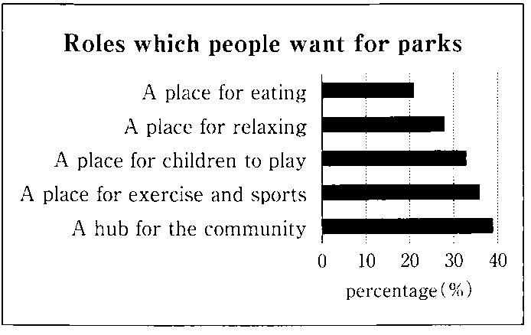
Tony: What are you going to *present in the next class?
Riku: I’m going to present my idea for a new park. I think people want many *roles for parks. They are important. I want to make a wonderful new park in my town in the future.
Tony: Great!
Riku: What is the most important role for parks to you?
Tony: Well, I think A place for eating is the most important.
Riku: I think that is important, too. But the *percentage for it is the lowest in this *graph.
Tony: Interesting. In my country, I often enjoy eating lunch in a park.
Riku: I think A place for children to play is the most important. Many other people also want that role.
Tony: Yes. The percentage for it is a little lower than the percentages for “A place for *exercise and sports” and “A *hub for the *community.” But it’s higher than the percentages for the other *items.
Riku: Parks can *play a lot of roles in a town. I’ll try to make a park that plays important roles. There are many *possible roles for a park in a town. I hope people find good roles for my park.
Tony: Great! I think your presentation will be really interesting. I want to know more about parks and towns.
[注] present：発表する role：役割 percentage パーセンテージ：graph：グラフexercise：運動
hub：拠点 communit：地域社会 item：項目 play：果たす possible：あり得る

Question
１．Tonyは，公園にとって最も重要な役割は何だと考えていますか？
２．Rikuは，公園にとって最も重要な役割は何だと考えていますか？

Answer
１．食事をする場所
２．子供が遊ぶための場所
※QuestionとAnswerは，ＡＩが作成しました。

都市と公園についてさらに学びたいと思ったRikuとTonyは，インターネットの画面を見ながら話をしている。グラフは，海外のある大学のオンライン講義の予定表であり，表中の時間は日本時間である。

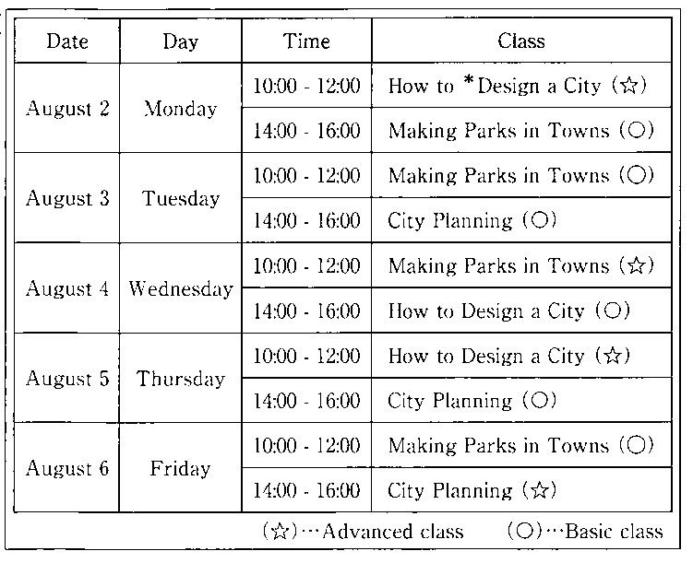
Riku: Tony, look! We can join some *online classes of the university.
Tony: Sounds interesting. I want to take one. I’m interested in City Planning.
Riku: Do you want to take a *Basic class or an *Advanced class?
Tony: I want to take a Basic class. But I talk with my family on the Internet every Thursday afternoon, so I can’t take it on that day.
Riku: Really? But you can take it on Tuesday afternoon, right?
Tony: Yes. I’ll take it. Riku, which class are you interested in the most?
Riku: I’m interested in Making Parks in Towns the most. In the future, I want to make some parks in Tokyo.
Tony: Great! But, Riku, can you take that class? I think you are busy with the tennis club.
Riku: We practice every Monday, Wednesday, and Friday in the afternoon. So I can take a morning class.
Tony: OK. Do you want to take a Basic class or an Advanced class?
Riku: I want to take an Advanced class.
Tony: So you’re going to take an online class on Wednesday morning, right?
Riku: Yes!
[注] online オンラインの basic 基本的な advanced 発展的な design デザインする

Question
１．Tonyが興味を持っているオンライン授業のテーマは何ですか？
２．Rikuが取りたい授業の曜日とレベルは何ですか？

Answer
１．都市計画に関する授業
２．水曜日午前の上級クラスの授業

※QuestionとAnswerは，ＡＩが作成しました。


次の文章は，イギリスに帰国したTonyがRikuに送ったＥメールの内容である。

Dear Riku,
Thank you for your help during my stay in Japan. Taking an online class of the university is a special memory for me. In the class, we learned how parks could make our lives better. Now I am very interested in parks and towns. Now I realize that parks are very important for towns.
After returning to my country, I *researched about parks in my town. I knew some big festivals were held in the parks. But I didn’t know that many other events were also held in them. I was a little surprised to learn that. I will tell my sister about those events. She will enjoy talking with people at them. I think parks are wonderful places for people to *communicate.
I’m going to join an online meeting about City Planning next week. I want to know more about parks and towns. What are some good points to you about having parks in towns? Please tell me some of your ideas.
Yours,
Tony
[注] research：調べる communicate：意思の疎通をする

Question
１．Tonyは帰国後，自分が住んでいる町の公園について調べました。どのような発見がありましたか。
２．Tonyは来週，何に参加する予定ですか？

Answer
１．町の公園で多くのイベントが開催されていること。
２．都市計画についてのオンラインミーティング。

※QuestionとAnswerは，ＡＩが作成しました。

