栃木県-大問３ |   2022年 公立高校入試
※QRコードを読み込むと，英文と連動した音声再生ができます（スマホにも対応）

次の英文は，中学生の真奈(Mana)と，イギリス(the U.K.)からの留学生アリス(Alice)との対話の一部である。また図は，総合的な学習の時間で二人が作成している，ツバメ(swallow)に関する発表資料である。

Mana: Where do swallows in the U.K. come from in spring, Alice?
Alice: Some of them come from *Southern Africa. They travel about 10,000 km.
Mana: Really? They can fly so far! How long do they fly to go to the U.K.?
Alice: I'm not sure, but for more than three weeks.
Mana: Wow. In Japan, swallows come from *Southeast Asia. It may take about a week. Then, they make their *nests under the *roof of a house.
Alice: Why do they choose people's houses for making nests?
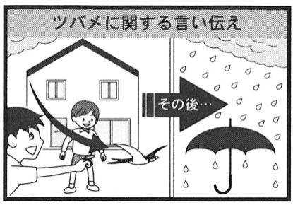
Mana: There are many people around the houses, so other animals don't come close to their nests.
Alice: I see. Do Japanese people like swallows?
Mana: Yes, and there are some words about swallows in Japan. One of them is, “If a swallow flies low in the sky, it will rain，it is going to rain.” I'll draw a picture of it later.
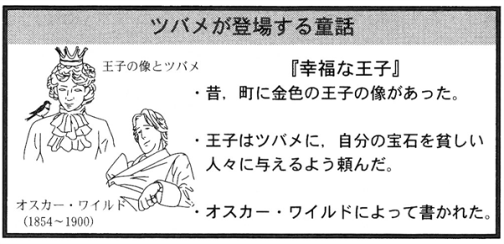
Alice: Interesting! Swallows are popular in my country, too. We have a story called *The Happy Prince. One day, there was a gold *statue of a prince in a city. The prince wanted to help poor people. He asked a swallow to give his *jewelry to them. The story was written by *Oscar Wilde.
Mana: Let's introduce the story to everyone. I also want to show（3)this graph. It says 36,000 swallows were found in our city in 1985. But only 9,500 swallows were found in 2020. *On the other hand, the number of houses has been growing for these 35 years.
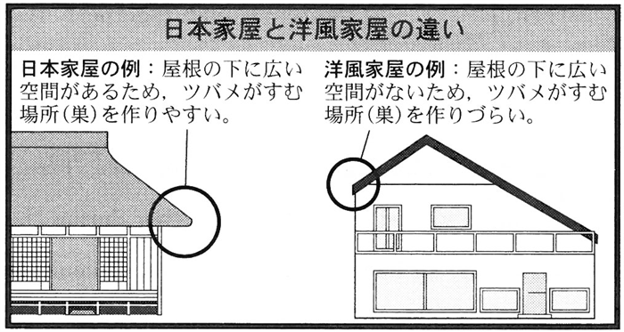
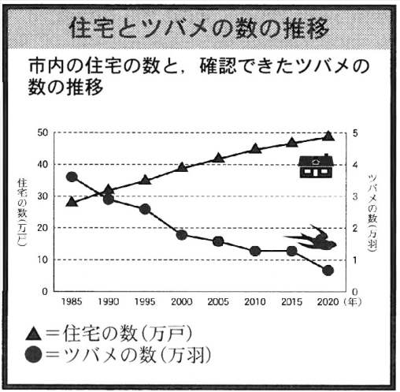

Alice: You said a human's house was a safe place for swallows, right? If there are many houses, that is good for them.
Mana: Well, actually, more people in Japan like to live in Western style houses. Traditional Japanese houses are good for swallows because those houses usually have wide *space under the roof. So, it is easy for them to make their nests. However, some Western style houses don't have space under the roof.
Alice: I see. Well, I think many swallows have other problems when they grow their babies. Their nests are sometimes broken by people. Also, baby swallows fall from their nests. They need a safe place.
Mana: You're right, Alice. Our city has got bigger, and its *nature was lost in many places. Living in this city is not easy for swallows because they can't find their food. We have to know more about *environmental problems.
Alice: That's true. We have to live in a nature-friendly way.

〔注〕 Southern Africa＝アフリカ南部 Southeast Asia＝東南アジア nest＝巣roof＝屋根
The Happy Prince＝『幸福な王子』(イギリスの童話 statue＝像 jewelry＝宝石
Oscar Wilde＝オスカー・ワイルド（イギリスの作家) on the other hand＝一方で space＝空間 nature＝自然
environmental＝環境の

Question
１．イギリスのツバメはどこから来ますか？
２．日本のツバメはどこから来ますか？
３．日本のツバメが，人間の家の屋根ののき下に巣を作るのはなぜですか？
４．イギリスで有名なツバメに関する物語は何ですか？
５．Manaたちの街にすむツバメの数は，1985年には（ ）羽だったが，2020年には（ ）羽まで減少した。
６．洋風家屋に比べて，伝統的な日本家屋がツバメにとって巣を作りやすいのはなぜですか？

Answer
１．南アフリカから，３週間以上かけてやって来る。
２．東南アジアから，１週間かけてやって来る。
３．家の周りにはたくさんの人がいるので，他の動物が巣に近づかないから。
４．オスカー・ワイルドによって書かれた「幸福な王子」。
５．36000，9500
６．屋根の下に広いスペースがあるから。

※QuestionとAnswerは，ＡＩが作成しました。

