栃木県-大問５ | 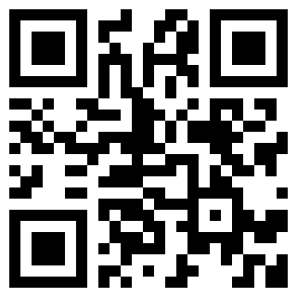  2022年 公立高校入試
※QRコードを読み込むと，英文と連動した音声再生ができます（スマホにも対応）

How many times do you look at a clock or a watch every day? To live without them is difficult today. Now, we can find many kinds of clocks and watches around us. It's very interesting to see them.
People in *Egypt used the sun to know the time about 6,000 years ago. They put a *stick into the ground and knew the time from its *shadow. However, there was one problem. The people couldn't use this kind of clock when they couldn't see the shadow. To solve the problem, they invented a clock that used water. It was useful because they could know the time when it was cloudy or night time.
They knew the time by *measuring the speed of dropping water and how much water was used. After that, a clock with sand was invented. It was good for people who were on *ships.
Do you know the floral clock? It tells us the time with flowers. Some flowers open about seven o'clock, and others open about noon. Like this, different kinds of flowers open at different times of a day. Around 1750, a *Swedish man used this point and chose *certain kinds of flowers. In this way, the floral clock was made. By seeing which flowers open, people can know the time. Flowers cannot tell the *exact time, but don't you think it's amazing?
A watch is another kind of clock. *Pocket watches were first invented in the 16th century, and people started to use *wrist watches around 1900. We can know the time at any place. Now, we can do many other things with a watch. For example, we can check our health.
People have invented many kinds of clocks and watches. If you could create a new watch, what kind of watch would it be?
〔注〕 Egypt：エジプト stick：棒 shadow：影 measure～：～を計る ship：船
Swedish：スウェーデンの certain：特定の exact：正確な pocket watch：懐中時計 wristwatch：腕時計

Question
１．約6000年前に，エジプトの人々は何を利用した時計を作りましたか？
２．１が利用できない時にも使うために，発明された時計は何ですか？
３．花時計では，どのように時を知ることができますか？
４．16世紀に発明された時計は何ですか？

Answer
１．日光
２．水時計
３．特定の花が開く時間によって，時を知ることができる。
４．ポケットウォッチ（懐中時計）

※QuestionとAnswerは，ＡＩが作成しました。

