熊本県-大問２-４ |   2022年 公立高校入試
※QRコードを読み込むと，英文と連動した音声再生ができます（スマホにも対応）

次は，高校生の由美（Yumi）と，ブラウン先生（Ms. Brown）との対話である。

Ms. Brown: Hi, Yumi. What are you doing now?
Yumi: I'm collecting information about how Japanese people communicate with people from other countries. I'm thinking about making a presentation about it.
Ms. Brown: Oh, that's interesting. What did you find out about it?
Yumi: Please look at the graph. Communication with gestures is the most popular way for Japanese people. I was surprised to find that the rate of talking in easy Japanese is almost as high as the rate of talking in foreign languages such as English.
Ms. Brown: That's a good point. I often feel that speaking to me in easy Japanese is as nice as speaking to me in English because I feel like a member of Japanese people.
Yumi: I see. I didn't know that. Next, please look at the table. We can see people in different ages choose different ways of communication. For example, the rate of people between 16 and 19 years old who use gestures is higher the rate of people in their 40s or 70s who use gestures.
Ms. Brown: You're right, and the rate of the youngest group of people using applications on smartphones is almost the same as the rate of people in their 70s talking in Japanese which they usually use.

(注) communicate with ～ = ～と意思の疎通を図る make a presentation = 発表をする graph = グラフ
gesture = 身ぶり rate = 割合 table = 表 in their 40s = 40歳代の application = アプリケーション（アプリ)
smartphone = スマートフォン the same as ～ = ～と同じ
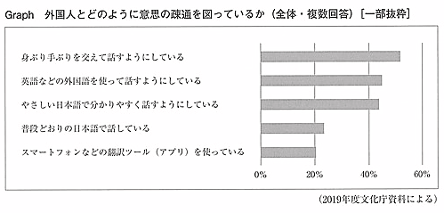

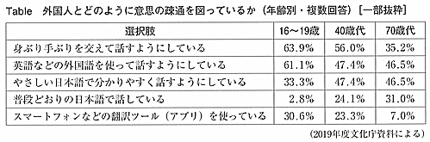

Question
１．Yumiは何について調べていますか？
２．日本人が外国人とコミュニケーションをとるとき，最も人気がある方法は何ですか？
３．日本人が外国人とコミュニケーションをとるとき，若い人と年配者の違いは何ですか？

Answer
１．日本人が外国人とどのようにコミュニケーションをとるのか。
２．ジェスチャー
３．若い人ほどスマートフォンアプリを使ってコミュニケーションをとることが多く，年齢が上がるにつれてジェスチャーでのコミュニケーションが多くなる。

※QuestionとAnswerは，ＡＩが作成しました。

