石川県-大問３ |   2022年 公立高校入試
※QRコードを読み込むと，英文と連動した音声再生ができます（スマホにも対応）

夏休みにアメリカでホームステイをしている高校生の葵（Aoi）さんと同級生の雅樹（Masaki）さんが，それぞれのホストファミリーのエミリー（Emily）さん，オリバー（Oliver）さんと話しています。
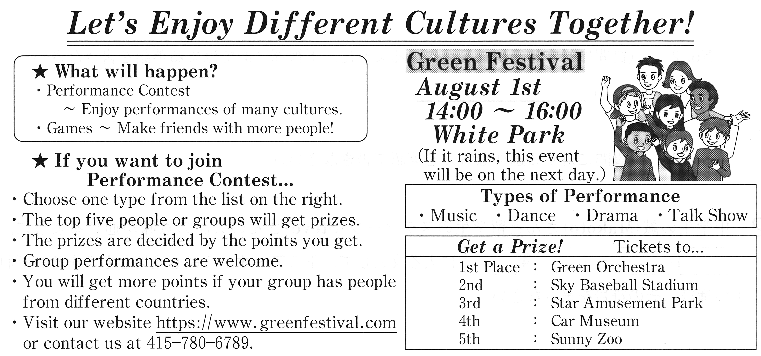
Oliver: Look! I brought a poster for an interesting event. This Saturday, an exciting event is going to be held in our community. Let's go together and have fun!
Emily: Oh, Green Festival. My favorite part is the performance contest of many cultures. Last year, I enjoyed the performance of students from Brazil. They performed a traditional dance and came in first place.
Masaki: Sounds interesting! It'll be fun to see performances from different cultures.
Aoi: But just watching performances is not as good as performing. Masaki, what do you think about joining the contest with me? Let's do something about Japanese culture together!
Masaki: OK. But what can we do? Do you have anything in mind?
Aoi: How about a calligraphy performance? It's getting popular with young people in Japan.
Emily: I know about calligraphy, but what is a calligraphy performance? I've never heard of it.
Masaki: It is a team activity. A group of people work together to make a big calligraphy work and they usually wear traditional Japanese clothes. They use big brushes and large paper. Japanese pop music is often played during their performance.
Oliver: Wow! I'm sure the audience will be surprised. I enjoyed calligraphy when I visited Japan last summer. I want to try this new type of calligraphy. Can I join you?
Masaki: Of course. Our performance will be more exciting if we have more people with us. Emily,
why don't you join us ?
Emily: Well... It'll be the first time for me to do calligraphy, but don't worry. I'll do my best!
Aoi: Have fun with us!
Masaki: OK, everyone will join the contest. Well, what type of performance will our performance be?
Aoi: Maybe, dance... because music is played when we are performing. What do you think?
Oliver: Umm... I'm not sure. OK, I'll call the office tomorrow and ask.
Aoi: Thank you. Emily, did you check the prizes?
Emily: No, let's see... Wow, I want to go to the concert by Green Orchestra. I'm a big fan of its top violin player.
Aoi: To me, the Ferris wheel in Star Amusement Park is more attractive! I saw it in a magazine before I came here. Let's go and ride it if we win the prize!
Masaki: Good idea, Aoi! According to the rules, we can get a prize more easily because
our group has people from different countries.
Oliver: Yes. We are American, and Aoi and Masaki are Japanese.
Emily: By working with people from different cultures in the same performance, we learn a lot.
Masaki: Oh, what can we learn? Give me one example.
Emily: We can learn to know cultural differences and respect each other's cultures.
Masaki: You're right, Emily. I think that is an important goal of this contest. Now, let's get ready for the performance!
(注) prize : 賞品，景品 brush : 筆

Question
１．グリーンフェスティバルとは何ですか？
２．去年のパフォーマンスで，エミリーは特に何を楽しみましたか？
３．calligraphy performanceとは何ですか？
４．グリーンフェスティバルの賞品について，エミリーとアオイはどのような希望を持っていますか？
５．グループパフォーマンスには，文化へのどのような価値がありますか？

Answer
１．様々な文化のパフォーマンスコンテストを含む，コミュニティで開催されるエキサイティングなイベント。
２．ブラジルの学生たちによる伝統的なダンス。
３．書道パフォーマンスのこと。大きな筆と大きな紙を使って，伝統的な日本の衣装を着たグループで作品を制作し，演奏される日本のポップ音楽と共にパフォーマンスを行うチームアクティビティ。
４．エミリーはGreen Orchestraのコンサートに行きたいと思っており，アオイはStar Amusement Parkの観覧車に乗りたいと思っている。
５．異なる文化背景を持つ人々が同じパフォーマンスに参加することで，お互いの文化を尊重し，文化の違いを理解することができるという価値がある。

※QuestionとAnswerは，ＡＩが作成しました。

