石川県-大問４ |   2022年 公立高校入試
※QRコードを読み込むと，英文と連動した音声再生ができます（スマホにも対応）

昨年の秋，英語の授業で，中学生の剛（Takeshi）さんが，クラスの生徒にプレゼンテーションをしました。

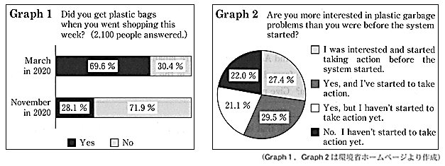

On a sunny summer day, when I was taking a walk along a beach, I came to a pretty small store and found works of art which looked like sea animals. They were so cute and I bought some. Then, a woman came up to me and told me she made them. She collected plastic garbage on the beach and made those dolphins out of it. When she saw a lot of plastic garbage there, she thought she should do something. She said, “Plastic garbage in the sea causes serious problems around the world. More people should know this fact.”
I became interested in the garbage problem and read the magazine she gave me. In it, I found the expression “disasters of sea animals.” It means more and more sea animals and fish die because of the plastic garbage they eat in the sea. The article also said there will be more plastic garbage than fish in 2050. It continued, “If we do not stop this, there will be no sea animals or fish in the sea.”
After reading this magazine, I thought we should work hard to solve this problem.
First, we should stop throwing away plastic garbage because it may go to the sea. However, it is more important to decrease the amount of plastic we use. The Japanese government started a new system in July 2020, and now we have to pay for plastic shopping bags. Look at Graph 1. It shows how many people got plastic bags in a week when they did shopping. From the graph, we can say this system is successful because fewer people got plastic bags in November than in March. Other research says when people get plastic bags, about 80% of the people use them again.
Now, look at Graph 2. It shows how people have changed since the system started. Some people have started to take action. There are some companies that have started to use less plastic. A famous coffee shop began to use paper straws instead of plastic straws. However, more than 40 % of the people haven't taken any action yet. How can we change these people?
The woman I met in the store on the beach said, “I like art, so making works of art is the easiest way for me to let more people know about plastic garbage in the sea.” The best way to solve this problem is to start with things we can enjoy.
I will introduce a good example. Last year, I joined “Supo-GOMI” with my brother and sister. During this event, people enjoyed collecting garbage on the beach as a sport. People made groups of three to five and collected garbage for an hour. Winners were decided by how much and what kind of garbage they got. We picked up many kinds of garbage on the beach. We were surprised to learn there was more plastic garbage than we thought.
I'm thinking of holding “Supo-GOMI” on a beach near our school. I hope everyone will have a good time and be interested in the plastic garbage problem. It will take a long time to solve it, so we should do things that we can continue. Our actions may be small, but if more people join us, the future of the sea will be different. What can you do for sea animals and fish? Everyone, let's take the first step to protect life in the sea.
(注) system : 制度 amount : 量 straw : ストロー winner : 勝者

Question
１．海のプラスチックゴミ問題によって，海洋生物はどうなっていますか？
２．2050年には，海洋中にプラスチックゴミの方が（ ）よりも多くなると懸念されています。
３．プラスチックゴミを減らすために，日本政府は2020年7月に何を始めましたか？
４．プラスチックゴミを減らすために，ある有名なコーヒー店はどのような取り組みをはじめましたか？
５．プラスチックゴミを減らすために，Takeshiさんはどのような活動を提案していますか？

Answer
１．死滅しつつある。
２．魚
３．プラスチック製のレジ袋の有料化。
４．プラスチック製ストローを紙ストローに変更した。
５．海岸でのごみ拾い競技「スポゴミ」を提案し，楽しみながら海のプラスチックゴミ問題に関心を持つことを呼びかけている。

※QuestionとAnswerは，ＡＩが作成しました。

