福井県-大問３ |   2022年 公立高校入試
※QRコードを読み込むと，英文と連動した音声再生ができます（スマホにも対応）

美保と光太，アメリカ出身のアレックスが，ベーカー先生の授業で，ニュースに関するグラフ（Graph）を見ながら話をしている。

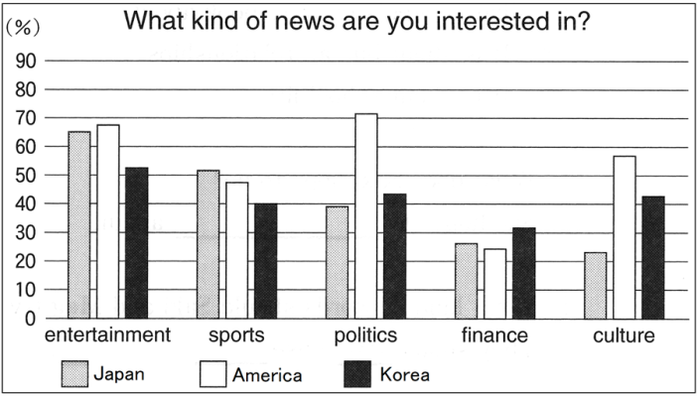
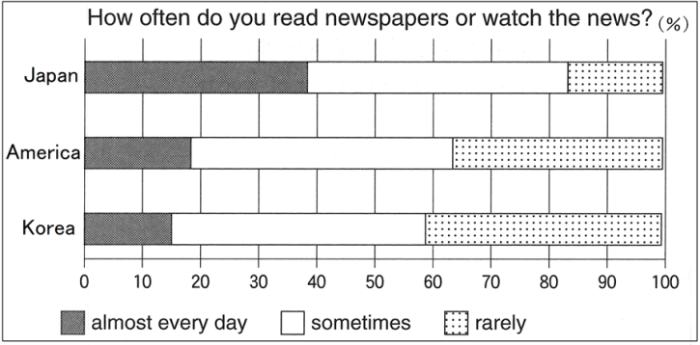

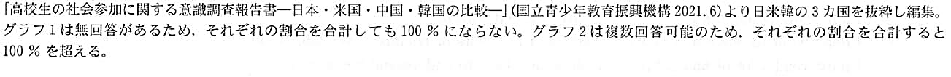
Ms. Baker: Today we're going to talk about newspapers and news. Do you read newspapers or watch the news?
Miho: Yes, I read newspapers every morning.
Kota: I often watched the news on TV before, but these days, I'm interested in reading newspapers. Our social studies teacher uses newspapers in class. We choose one interesting article and talk about it in each group. I can hear different opinions from other students. Such classes are interesting to me.
Alex: I rarely read newspapers or watch the news, but I think it's important to know what is happening around the world.
Kota: I think reading newspapers is a better way to get a lot of information than watching the news. Newspapers include a wider variety of articles such as politics, culture, and sports.
Miho: Yes! We can become interested in things we don't know and get a lot of information about them. Also, newspapers help us learn about a lot of things in our communities such as events or volunteer activities. For example, we can learn that some people do something helpful for their own cities.
Ms. Baker: Thank you for talking about the good things about newspapers. Look at Graph 1. This graph shows how often high school students read newspapers or watch the news. What can we learn from it?
Kota: The percentage of the Japanese high school students who said, “almost every day”, is the highest of the three countries.
Alex: Almost forty percent! That's great. In Japan, about seventeen percent of the students rarely read newspapers or watch the news, but in America and Korea, about forty percent of the students rarely do that.
Kota: I'm surprised to know that. What kind of news are the high school students interested in?
Ms. Baker: Look at Graph 2. What can we learn from it?
Alex: In all the countries, more than fifty percent of the high school students are interested in the news about entertainment such as movies or songs.
Miho: I can see that high school students are not interested in finance. Korea has the highest percentage, but it is only about thirty percent. I think it's hard for students to understand finance.
Kota: Look! The percentage of the American students who are interested in the news about politics is higher than the percentage in Japan and Korea. It's more than seventy percent! Japanese high school students often read newspapers or watch the news, but they are less interested in politics than American students.
Miho: Ms. Baker, when you were a high school student, were you interested in politics?
Ms. Baker: Yes, I had classes about politics in my high school. In the classes, we had to tell other students our opinions about a topic, so we needed to think about it a lot. Through the classes, I learned a lot and became interested in politics.
Miho: I see.
Alex: When people are eighteen, they can vote. It started about fifty years ago in America, but in Japan, it started just six years ago. Now Japanese students can learn the importance of voting in social studies classes. I think more and more young people in Japan will be interested in politics.
Kota: I hope so. Now, there are many problems in our countries, so it's important for us to become more interested in them. We should read newspapers or watch the news, think about these problems, and have our own opinions about them.
Ms. Baker: That's right. Thank you, everyone. You are a member of your country. When you become eighteen, you can tell the government your opinion by voting. Each person's voice may be small, but if it is collected together, it can become a very big voice. You can change your countries for the better!
（注) rarely ～ めったに～ない entertainment エンターテイメント finance 金融
percentage 割合 American アメリカ人の

Question
１．Kotaがニュースに興味を持つようになったのはなぜですか？
２．生徒たちはなぜ新聞を読むことが良いと考えていますか？
３．高校生が興味のあるニュースのジャンルは何ですか？
４．アメリカ，韓国，日本の高校生の内，新聞を読む割合が最も高いのはどこですか？
５．アメリカ，韓国，日本の高校生の内，政治ニュースへの関心が最も低いのはどこですか？

Answer
１．社会科の先生が新聞を使って授業をしているため。
２．新聞には政治や文化，スポーツなど，様々な記事が含まれ，多くの情報を得ることができ，自分たちが知らなかったことに興味を持つことができるから。
３．エンターテインメント
４．日本
５．日本

※QuestionとAnswerは，ＡＩが作成しました。

