群馬県(前)-大問４ |   2022年 公立高校入試
※QRコードを読み込むと，英文と連動した音声再生ができます（スマホにも対応）

次の英文は，ALTのBrown先生（Ms. Brown）が，県立ぐんま天文台（Gunma Astronomical Observatory）で日時計（sundial）を見たことに触れ，英語の授業で話した内容です。

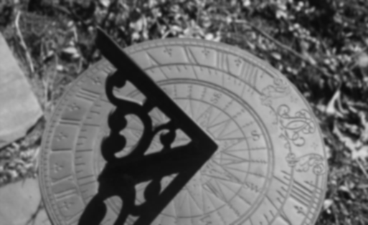
Last Sunday, I visited Gunma Astronomical Observatory with our science teacher, Ms. Tanaka. When we arrived there, I saw something large outside. I asked Ms. Tanaka, “What is this large thing?” Ms. Tanaka said, “It is a sundial. It is a kind of clock which uses *shadow. You can know the time by the *position of the shadow. This kind of clock was the first clock in history.” Then she told me about the history of clocks and watches. It was very interesting, so I will talk about it today.
About 6,000 years ago, people in *Egypt made the first sundial. Sundials were useful. But people couldn't use them at night or when it was cloudy. Later, people started to use water to make clocks. They *were able to know the time at night with water clocks. But in cold areas, water becomes ice in winter. About 700 years ago, people in *Europe started to make new clocks which did not use shadow or water. They were *mechanical clocks, and they were large and heavy. So people wanted to make smaller clocks. About 500 years ago, people started to make watches. People were able to wear them, so they always knew the time.
People in many parts of the world have been looking for a better way of knowing the time. Today, many people have watches, and you can find clocks in so many places. They are in our houses, in our classrooms, in stations, and in shops. Clocks and watches are very useful in our lives today. Knowing the right time is very important for us. I had some troubles when I didn't know the right time. Do you have any experiences like that?
(注) shadow 影 position 位置 Egypt エジプト be able to ～ ～することができる
Europe ヨーロッパ mechanical 機械式の

Question
１．Ms. Brownは日曜日にどこに行き，何を見ましたか？
２．最初の時計を作ったのは誰ですか？
３．夜間や曇っている時に時間を知るために，古代の人がつくった時計は何ですか？
４．約700年前にヨーロッパの人々がつくった時計は何ですか？
５．腕時計にはどのような利点がありますか？

Answer
１．群馬天文台に行き，大きな日時計を見た。
２．約6,000年前のエジプト人
３．水時計
４．機械式の時計
５．身に着けていつでも時間を知ることができる。

※QuestionとAnswerは，ＡＩが作成しました。

