茨城県-大問４ |   2022年 公立高校入試
※QRコードを読み込むと，英文と連動した音声再生ができます（スマホにも対応）

高校生のシホ (Shiho) とクラスメイトのアナ (Anna) が，次のページのウェブサイトを見ながら話をしています。

Anna: Hi, Shiho. What are you doing?
Shiho: I'm looking at Hibari Zoo's website. I will go there with my family. Do you want to come with us, Anna?
Anna: Yes! When will you go?
Shiho: How about this Saturday?
Anna: Sorry, I have a piano lesson this Saturday until three in the afternoon at the City Hall.
Shiho: No problem. We'll go there in the evening. The tickets will be cheaper. Look at the website.
Anna: That's true. Then, each person can save 300 yen.
Shiho: Yes. Also, you should bring your student card . If you don't show it when you buy a ticket, you can't get the student *discount.
Anna: Okay. Hey, how can I get to the zoo?
Shiho: My family and I will go there by car. *Do you want a ride?
Anna: Thank you, but I'll go *directly from the City Hall. It's *far from your house, right?
Shiho: Then you should take the bus ... Look at this page. There is a *timetable.
Anna: There are two lines. Which line should I take?
Shiho: Hmm ... If you take the Blue Line, you need 25 minutes to get to the zoo. If you take the Red Line, 35 minutes.
Anna: All right. Can we meet at the *entrance?
Shiho: Yes. How about meeting at four o'clock?
Anna: Then I'll take the bus at three twenty-five.
Shiho: Anna, which event would you like to go to? They have four kinds of events.
Anna: Really? I like big animals, but I cannot pay a lot of money. I can use only 3,000 yen this week.
Shiho: Then how about " Taking pictures with elephants "?
Anna: That sounds great! It will be fun.

*discount 割引 Do you want a ride? 乗っていく？ directly 直接 far 遠い
timetable 時刻表 entrance 入口

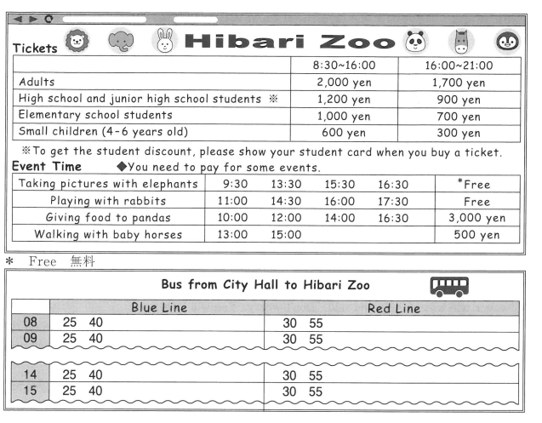

Question
１．Shihoは何をしていますか？
２．今週の土曜日の午後3時まで，Annaはどこで何をする予定が入っていますか？
３．動物園のチケットを安く入手する方法は何ですか？
４．動物園に行くために，Annaは何時のバスに乗ることにしましたか？
５．Annaは何のイベントに参加することにしましたか？

Answer
１．ヒバリ動物園のウェブサイトを見ている。
２．市役所でピアノのレッスンの予定がある。
３．夜に行くとチケットが安くなる。
４．午後３時25分
５．「象と写真を撮る」イベント

※QuestionとAnswerは，ＡＩが作成しました。

