長崎県-大問３ |   2022年 公立高校入試
※QRコードを読み込むと，英文と連動した音声再生ができます（スマホにも対応）

次は，中学３年生の春希（Haruki）とALT（外国人指導助手）のスミス先生（Ms. Smith）との会話である。

Haruki: Our school brass band club will have a concert next Sunday. Did you know that?
Ms. Smith: No, I didn't. That sounds interesting. What time will the concert start?
Haruki: At 2 p.m. I'll give you this Leaflet.
Ms. Smith: Thank you. I think I can go.
Haruki: Great! Our members will be happy to hear that.
Ms. Smith: In this Leaflet, what does this last sentence mean?
Haruki: Oh, yes. After the concert, the guest will teach you how to play the guitar.
Ms. Smith: Thank you. I want to try it.
Haruki: I hope you'll enjoy the concert.
（The next day after the concert)
Haruki: How was the concert?
Ms. Smith: It was great, and playing the guitar was also interesting. I had a wonderful experience. Well, what do you want to do during the spring vacation before you become a high school student?
Haruki: I want to read a lot of books because I don't have time to read now.
Ms. Smith: Nice. Have a good vacation.

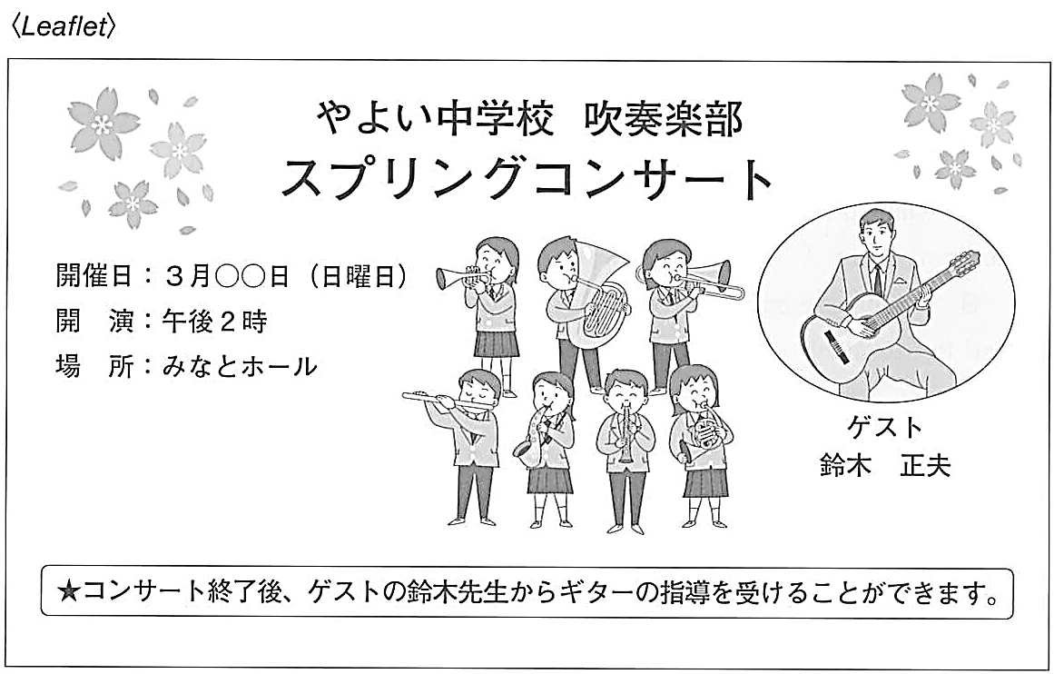
注：brass band club 吹奏楽部 leaflet (広告の）ちらし sentence 文 guest ゲスト

Question
１．Harukiの吹奏楽部のコンサートはいつ行われましたか？
２．リーフレットに書かれている最後の文章は何を意味していますか？
３．コンサートの後，Ms. Smithはどのような感想を持ちましたか？

Answer
１．日曜日の午後２時から。
２．コンサートの後にゲストがギターの弾き方を教えてくれること。
３．コンサートは素晴らしく，ギターを弾くことも面白かった。

※QuestionとAnswerは，ＡＩが作成しました。

